This is a notification that an addendum to the **Request for Proposals (RFP)** for **DSCSA Compliance Storage Solution, Reference # 33993** has been posted on the [OSP (Office of State Procurement) website](https://osp.admin.mn.gov/GS-auto).

This addendum is answers to questions we have received regarding the DSCSA Compliance Storage Solution RFP. It is recommended that the addendum be downloaded and reviewed prior to submitting a response to this solicitation.

As a reminder: Although the MNIT SLM Workbook Template, Cost Proposal and Agreement Template are titled “Addendum 1”, “Addendum 2”, and “Addendum 3” respectively, it is worth noting that these are ***NOT*** addendums. System limitations prevented us from changing the naming conventions of these documents.

* Download solicitation PDF and subscribe = DSCSA RFP
* Addendum 1 = MNIT SLM Workbook Template
* Addendum 2 = Cost Proposal
* Addendum 3 = Agreement Template
* Addendum 4 = Addendum 1
* Addendum 5 = Addendum 2

Please follow the instructions below to download the RFP documents:

1. Go to the [OSP (Office of State Procurement) website](https://osp.admin.mn.gov/GS-auto), search for reference # 33993 = DSCSA Compliance Storage Solution
2. Click on the download button in blue:

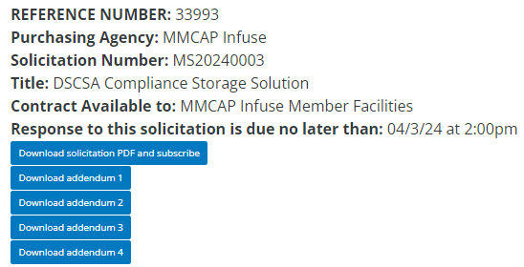

1. Insert an email address and click submit.

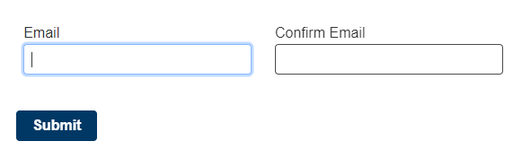

1. You will be redirected to the next page, click on the “Thank you” message to download:

Download solicitation PDF and subscribe = RFP Document



Download addendum 1 = MNIT SLM Workbook Template



Download addendum 2 = Cost Proposal



Download addendum 3 = Agreement Template



Download addendum 4 = Addendum 1



Download addendum 5 = Addendum 2



1. There should be a pop-up to view the document or check your right-hand corner of the window for the document.