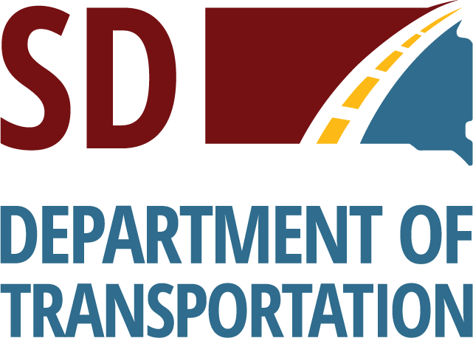 | Division of Finance & Management  Office of Air, Rail & Transit  700 East Broadway Avenue  Pierre, SD 57501  O: 605.773-3574 | F: 605.773.2804  dot.sd.gov

December 13, 2022

TO: Potential Proposers
FROM: Brenda Sharkey, Transportation Specialist
RE: Amended Narrow Body Procurement

The following amendments were made to 22IFB8250
Description of Work section and Narrow body bus spec section edited from Aftermarket bus door to OEM sliding door on all medium roof vans.
- Light Duty Van, 130” WB, SRW, Medium Roof, GVWR 8,550
Min 4 Passenger w/1 WC Location, OEM Sliding Door, Rear Lift., Base Order 1
- Light Duty Van, 130” WB, SRW, Medium Roof, GVWR 8,550, OEM Sliding Door
Min 9 Passenger. Base Order 1
- Light Duty Van, 148” WB, SRW, Medium Roof, GVWR 9,250, OEM Sliding Door
Min 6 Passenger w/1 WC Location, Rear Lift. Base Order 1
- Light Duty Van, 148” WB, SRW, Medium Roof, GVWR 9,150, OEM Sliding Door
Min 14 Passengers. Base Order 1

